DOCUMENT A

Now, therefore I, Abraham Lincoln, President of the United States, by virtue of the power in me vested as Commander-in-Chief, of the Army and Navy of the United States in time of actual armed rebellion against the authority and government of the United States, and as a fit and necessary war measure for suppressing said rebellion […] and designate as the States […] are this day in rebellion against the United States, the following, to wit:
Arkansas, Texas, Louisiana, Mississippi, Alabama, Florida, Georgia, South-Carolina, North-Carolina, and Virginia.
And by virtue of the power, and for the purpose aforesaid, I do order and declare that all persons held as slaves within said designated States, and parts of States, are, and henceforward shall be free; and that the Executive government of the United States, including the military and naval authorities thereof, will recognize and maintain the freedom of said persons.
And I hereby enjoin upon the people so declared to be free to abstain from all violence, unless in necessary self-defense. […]
And I further declare and make known, that such persons of suitable condition, will be received into the armed service of the United States to garrison forts, positions, stations, and other places, and to man vessels of all sorts in said service. […] In witness whereof, I have hereunto set my hand and caused the seal of the United States to be affixed.

Abraham Lincoln, January 1, 1863, Washington, D.C.

DOCUMENT B

In America, slavery died a painful death on the ground. During the Civil War, enslaved people did not wait for White liberators. They saw many of their slaveholders leave to fight, and so they left for freedom. Enslaved people by hundreds of thousands ran away to Union lines and Northern cities to escape their bondage. Their massive migration forced the nation to place the end of slavery on the national political agenda.
We have looked for abolition in all the wrong places. Freedom did not come from the White House or Congress. Black people were not given freedom; they forced freedom to become a national mandate. […]
While we can credit Lincoln’s Emancipation Proclamation formally, it was abolitionist and national leader Frederick Douglass who convinced Lincoln to use freedom as a weapon. Douglass pushed Lincoln to make abolition the heart and cause of the war. He persuaded Lincoln to allow Black men to fight and serve in the military, and to compensate them equally. Unbeknownst to many, Douglass is the real hero behind much of Lincoln’s success. Douglass was, as David Blight suggests, “America’s prophet of freedom.”
He not only called out American hypocrisy but also, along with women, clearly saw the path forward.
The Thirteenth Amendment, which originated with the Women’s National Loyal League, led by Elizabeth Cady Stanton and Susan B. Anthony, was akin to a coroner’s report. It marked slavery’s official time of death. When the Civil War finally ended, Lincoln admitted, “I claim not to have controlled events but confess plainly that events have controlled me.
Jackson, K. C (2025, May 7)
Lincoln gets way too much credit for freeing enslaved Black people
The Emancipator

DOCUMENT C
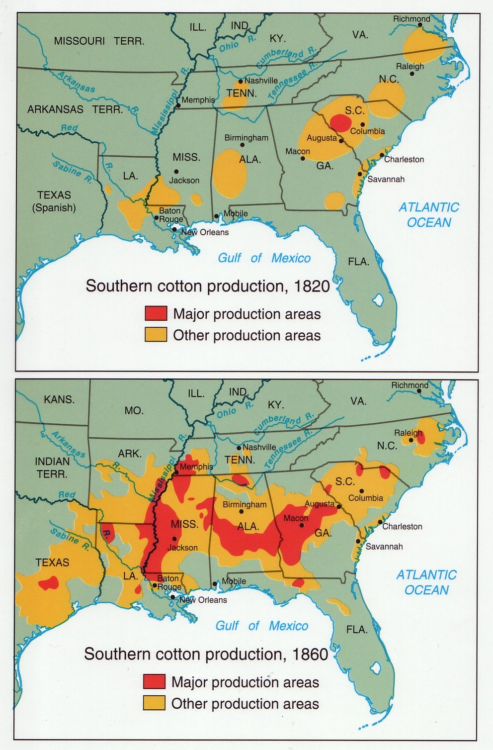
“US Slave Trade America United States Slavery History Map.” Tripod.com, 2025

