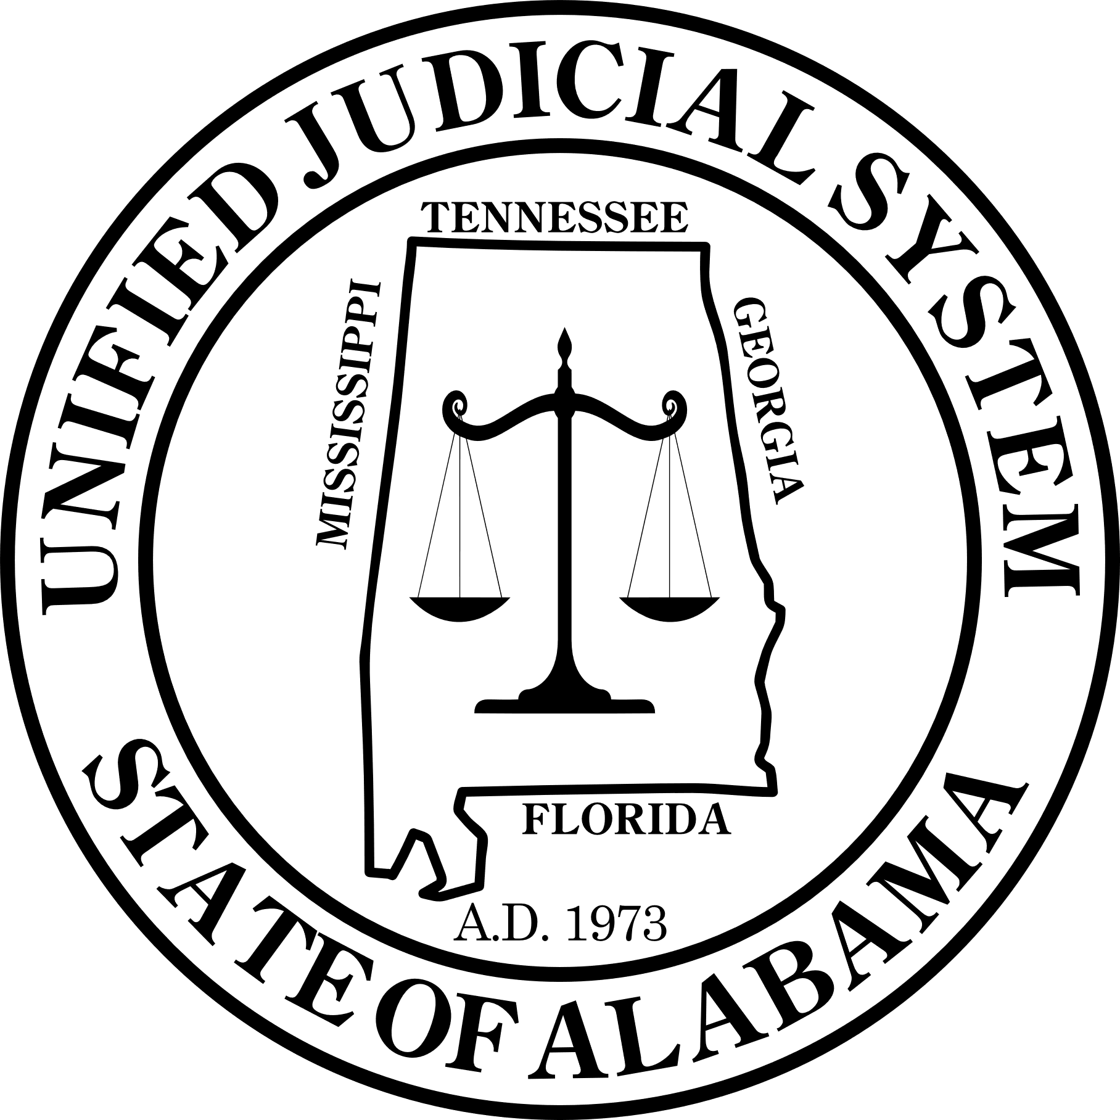**COURT REPORT:** State of Alabama vs. Walter McMillian

**Charge**: Murder of Ronda Morrison

**Prosecution**: State of Alabama

**Defendant**: Walter McMillian

**Summary of Events:**

Walter McMillian stands accused of the brutal murder of Ronda Morrison, a white woman, at the Monroeville Dry Cleaners on November 1, 1986 at 9am. The prosecution argues that McMillian, motivated by personal animosity and a prior history with the victim, committed the murder. Based on the evidence presented, the State strongly contends that McMillian is guilty beyond a reasonable doubt.

You will all take on the role of a defense lawyer in the case of Mr. McMillian, who has been convicted of a crime he may not have committed. Your task is to find the truth, present the evidence, and prove Mr. McMillian’s innocence to the jury in a **speech** that you will **write individually**.

**Using Evidence:**

* You will have documents, testimonies, and a video extract that provide evidence both for and against Mr. McMillian.
* Carefully review all the materials provided to you, paying particular attention to any contradictions, gaps in the prosecution’s argument, and evidence supporting Mr. McMillian’s alibi.

**Presenting Your Arguments:**

* Your arguments must **challenge** the prosecution’s claims and raise **reasonable doubt** about Mr. McMillian's involvement in the crime.
* **Focus on key evidence** that supports Mr. McMillian’s innocence, such as alibi testimonies, inconsistencies in the prosecution’s case, and the lack of physical evidence linking him to the crime.
* **Use link words** to connect your ideas and make your arguments clear and concise (e.g., "On the one hand," "In contrast," "However," "Moreover").

**Monroeville Police Department** **Official Report**  
**Reporting Officer:** Sheriff Tate  
**Date:** November 10, 1986  
**Report Number**: 9B3

**Subject**: Testimony of Ralph Myer – Alleged Observations of McMillian at Crime Scene

Ralph Myer testified under oath about his actions on the morning of Ronda Morrison’s murder. Myer revealed that at approximately 9am he drove Walter McMillian to the scene of the crime, when McMillian entered the building alone, he described hearing "popping sounds" as he waited outside. Upon entering the building, he discovered McMillian standing over the lifeless body of Ronda Morrison, holding a gun, and robbing her.

Although Myer did not witness the shooting itself, he was adamant that McMillian was present at the scene shortly after the shots were fired and was able to clearly identify him. He confirmed he had a clear view of McMillian's actions inside the building and was confident it was him.

**Monroeville Police Department** **Official Report**  
**Reporting Officer:** Sheriff Tate  
**Date:** November 15, 1986  
**Report Number**: 5LZ

**Subject**: Testimony of Bill Hooks – Alleged Observations of McMillian at Crime Scene

At approximately 9:15 AM on the morning of November 1, 1986, Bill Hooks, a local resident, reported that he was passing near the Monroeville Dry Cleaners when he noticed an unfamiliar truck parked nearby. Hooks stated that he had seen the truck in the area before but could not recall who it belonged to. He claimed that he initially did not pay much attention until he heard what he described as “loud cracks,” resembling gunfire, coming from inside the building.

Curious about the noise, Hooks said he approached the dry cleaners cautiously but did not go inside. He reported seeing a man—whom he later identified as Walter McMillian—rushing out of the building. According to Hooks, McMillian appeared hurried and was tucking something under his jacket.

After a few moments, Hooks claimed he saw another man, whom he later identified as Ralph Myer, enter the building. Hooks did not immediately follow but stated that when Myer came back out, he looked "shaken up." When asked if he had personally witnessed the crime itself, Hooks stated that he did not see the shooting but was certain that the series of events indicated something violent had occurred inside the dry cleaners.

**Monroeville Police Department** **Official Report**  
**Reporting Officer:** Sheriff Tate  
**Date:** November 6, 1986  
**Report Number**: 49D

Minnie Jackson stated that on the morning of the crime, she attended a church-sponsored fish fry at New Hope Baptist Church on County Road 21. The event started around 8:30 AM and lasted through the afternoon. She recalled seeing Walter McMillian at the event, helping prepare the food and speaking with other churchgoers.

*"I remember Walter being there plain as day. He was laughing, talking, helping fry fish. Everybody saw him. He wasn’t off by himself, neither—he was right there with the men, cooking outside near the hall,"* Jackson said.

**Monroeville Police Department** **Official Report**  
**Reporting Officer:** Sheriff Tate  
**Date of Report:** November 16, 1986  
**Report Number:** A3B  
**Subject:** Bill Hooks – Case Dismissal  
**Charge(s):** Robbery (Case #85-2093)

**Case Summary:**

On November 10, 1986, all charges against Bill Hooks related to Case #85-2093 (Robbery) have been officially dropped. Hooks was previously facing prosecution for his alleged involvement in the robbery of a Monroeville hardware store in July of 1985. However, per orders from higher authorities, the case will not proceed further.

Hooks was scheduled to appear in court later this month, but those proceedings have been canceled. No further action will be taken regarding this case, and no official statement has been provided as to why the charges were dismissed.

Hooks was notified of the dismissal earlier this morning and declined to comment.

**Monroeville Police Department** **Official Report**  
**Reporting Officer:** Sheriff Tate  
**Date:** November 20, 1986  
**Report Number**: K9S

On November 12, 1986, Darnell Houston voluntarily appeared at the Monroeville Police Department to provide a statement regarding the events of November 1, 1986, the morning of Ronda Morrison’s murder.

Houston stated that he was working at Thompson’s Auto Repair on the morning of the crime and was accompanied by Bill Hooks, who was also scheduled to work that day. Houston explained that both he and Hooks arrived at the shop at approximately 8:45 AM and remained there throughout the morning performing routine maintenance on vehicles. He specifically recalled working on a blue Ford pickup truck alongside Hooks at the time the murder allegedly took place.

When asked whether Hooks left the shop at any point, Houston was adamant that Hooks did not leave the premises during their shift.

**Monroeville Police Department** **Official Report**  
**Reporting Officer:** Sheriff Tate  
**Date:** November 6, 1986  
**Report Number**: 49D

Sharon Davis recalled that on the morning of the crime, she attended the church-sponsored fish fry at New Hope Baptist Church on County Road 21. The event began around 8:45 AM and lasted into the afternoon. She vividly remembered Walter McMillian being present, helping with the food preparation and mingling with the other attendees.

"I remember Walter clearly," Davis said. "He was outside by the cooking area, laughing with the men and checking on the fish frying. He wasn’t alone at any point. There were several people around him, and he was busy helping the whole time."

Later in the morning, Davis saw McMillian again, but this time inside the church. He was in the fellowship hall, organizing a group of children to help pass out plates and drinks for the attendees. "I even spoke to him for a moment when he was guiding the kids on where to set the drinks. He was right there, working alongside everyone, making sure everything went smoothly."

**STATE OF ALABAMA**   
**CIRCUIT COURT OF MONROE COUNTY**  
**CASE NO. 86-PR-1175**

**ORDER FOR ARREST**

TO: **ANY LAW ENFORCEMENT OFFICER OF THE STATE OF ALABAMA**

WHEREAS, probable cause has been established that the defendant, **DARNELL HOUSTON**, did willfully and knowingly provide false testimony under oath in an official investigation regarding the case of **State of Alabama v. Walter McMillian**, the following charges are brought against him:

**CHARGE:**

**Perjury in the First Degree** in violation of **Alabama Code § 13A-10-101**, a Class C felony.

It has been determined that the defendant’s statement, made under oath on **November 20, 1986**, contains material contradictions to sworn testimony provided in official court proceedings. The intentional falsification of testimony presents an obstruction to justice and undermines the integrity of this investigation.

**ORDER OF ARREST**

By the authority vested in this court, it is hereby **ORDERED AND DIRECTED** that any duly authorized law enforcement officer of the State of Alabama shall:

1. **Take the said DARNELL HOUSTON into custody forthwith.**
2. **Transport the defendant to the Monroe County Jail for booking and processing.**
3. **Ensure that the defendant is held without bail pending his initial court appearance.**
4. **Report the execution of this order to the Circuit Court of Monroe County.**

**ISSUED UNDER SEAL AND AUTHORITY OF THE COURT**

**Signed this 22th day of November, 1986.**

**Criminal Record of Ralph Myer**

**Subject:** Ralph Myer  
**Date of Birth:** March 1, 1935  
**Place of Birth:** Monroeville, Alabama  
**Gender:** male | **Ethnicity:** white | **Height:** 5’ 9”  
**File Number:** 07865432  
**Criminal History Report – State of Alabama**

* **October 22, 1973** – *Public Intoxication*  
  **Charge:** Disorderly conduct and public intoxication in a Monroeville bar. Myer was fined $100 and given a warning.   
  **Sentence:** Fine and warning.
* **May 7, 1978** – *Possession of Controlled Substance*  
  **Charge:** Possession of a small amount of marijuana in his vehicle. Myer pleaded guilty and was sentenced to 3 months in jail, which was later reduced to house arrest.   
  **Sentence:** 3 months in jail (reduced to house arrest).
* **December 3, 1980** – *Assault*  
  **Charge:** Involved in a physical altercation outside a bar, where he struck another man during a heated argument. He was charged with assault but received probation after the victim did not press charges.   
  **Sentence:** Probation.
* **October 28, 1986** – *Murder Suspicion* (Escambia County)  
  **Charge:** Myer became the main suspect in the murder of a local woman, found dead near the outskirts of Escambia County. Witnesses reported seeing Myer in the vicinity shortly before the murder.   
  **Sentence:** Awaiting trial for the death penalty

**Criminal Record of Bill Hooks**

**Subject:** Bill Hooks  
**Date of Birth:** February 23, 1952  
**Place of Birth:** Monroeville, Alabama  
**Gender:** male | **Ethnicity:** black | **Height:** 5’ 6”  
**File Number:** 08645372  
**Criminal History Report – State of Alabama**

* **October 25, 1986** – *Robbery & assault* **Charge:** Robbery in a Monroeville bar.  
  On the evening of October 22, Hooks allegedly entered a local bar in Monroeville, where an altercation ensued with the bartender over an unpaid tab. In the heat of the argument, Hooks is accused of threatening the bartender with a weapon and forcibly taking cash from the register. The robbery was interrupted when a patron called the police, and Hook was apprehended shortly after leaving the bar.  
  **Sentence:** 2 years of probation and required to complete 200 hours of community service.

**Criminal Record of Darnell Houston**

**Subject:** Darnell Houston  
**Date of Birth:** July 7, 1956  
**Place of Birth:** Monroeville, Alabama  
**Gender:** male | **Ethnicity:** black | **Height:** 5’ 10”  
**File Number:** 0294872  
**Criminal History Report – State of Alabama**

**November 20, 1986**

* **November 20, 1986** – Perjury in the First degree  
  **Charge:** Darnell Houston deliberately provided false information under oath or affirmation, knowing that the information is false, in a legal proceeding.  
  **Sentence:** Awaiting trial

**Criminal Record of Minnie Jackson**

**Subject:** Minnie Jackson  
**Date of Birth:** December 29, 1934  
**Place of Birth:** Monroeville, Alabama  
**Gender:** female | **Ethnicity:** black | **Height:** 5’ 2”  
**File Number:** 09382774  
**Criminal History Report – State of Alabama**

*The State of Alabama hereby certifies that there are no prior   
convictions or charges on record for Minnie Jackson*

**Criminal Record of Sharon Davis**

**Subject:** Sharon Davis  
**Date of Birth:** December 12, 1947  
**Place of Birth:** Monroeville, Alabama  
**Gender:** female | **Ethnicity:** black | **Height:** 5’ 4”  
**File Number:** 09239841  
**Criminal History Report – State of Alabama**

*The State of Alabama hereby certifies that there are no prior   
convictions or charges on record for Sharon Davis*

**THE MONROE JOURNAL**   
**October 20, 1986**

**SHERIFF TATE ELECTED AS MONROEVILLE'S NEW LAW ENFORCEMENT LEADER**

***Promises 'Law and Order' as He Takes Office***

Monroeville residents have spoken, and their votes have secured the election of Sheriff Thomas Tate as the city’s new head of law enforcement. Running on a platform of strong justice and a commitment to keeping the community “safe and orderly,” Tate has taken full advantage of the growing anxieties in the city, securing a decisive victory over his opponent.

During his acceptance speech Tuesday night, Tate assured citizens that he would crack down on crime, vowing to make Monroeville a place “where justice is swift and unwavering.” Supporters cheered as he promised to bring stability to the county, a promise that resonated with many who fear increasing tensions in the area.

Sheriff Tate is determined to prove he has earned his position, making a concerted effort to build a reputation as a tough, no-nonsense lawman. Lately, he has been racking up convictions, showing the community and his colleagues that he is committed to keeping the streets safe. With each high-profile case, Tate aims to solidify his authority and demonstrate that he is not only capable but relentless in his pursuit of justice.

**STATE OF ALABAMA  
OFFICE OF RECORDS AND LEGAL AFFAIRS  
MONTGOMERY, ALABAMA**

**OFFICIAL NOTICE TO LAW STUDENTS**

**Date:** March 17, 2025 **Subject:** Verification of Legal Competency for Archival Request Approval

The State of Alabama holds its legal practitioners to the highest standards of excellence, integrity, and knowledge. Before granting access to official archival records, the Office of Records and Legal Affairs requires that all students seeking such requests demonstrate their legal proficiency.

**INSTRUCTIONS**

1. **A crossword puzzle with pink and white squares

   AI-generated content may be incorrect.**Complete the attached **Justice & Law Crossword Challenge** using your expertise of the case. All words can be found in the documents
2. Identify the hidden password within the completed crossword.
3. Submit your completed crossword and the discovered password to the **Office of Records and Legal Affairs** for verification.
4. Upon successful completion, your request for archival access will be reviewed

|  |  |  |  |  |  |  |  |  |  |
| --- | --- | --- | --- | --- | --- | --- | --- | --- | --- |
| 1 | 2 | 3 | 4 | 5 | 6 | 7 | 8 | 9 | 10 |

|  |  |
| --- | --- |
| **ACROSS**  5. You must swear to tell the truth.  6. They saw it happen firsthand.  8. Proof that can be shown in trial.  9. Justice is served in this place. | **DOWN**  1. The one who brings the case forward.  2. To stand firm despite strong opposition. 3. A formal written or spoken statement. 4. Person accused in a legal case. 7. Offence of willfully telling a lie. |

**STATE OF ALABAMA  
OFFICE OF THE GOVERNOR  
DEPARTMENT OF CORRECTIONS  
MONTGOMERY, ALABAMA**

**OFFICIAL RECORDS REQUEST - ARCHIVAL DOCUMENT**

**Reference No.: AL-DOC-1988-34567  
Subject: Sentence Reduction for Ralph Myers**

**Name:** Ralph Myers  
**DOC ID:** 24891-AL  
**Original Sentence:** Death Penalty  
**Offense:** Accomplice to Capital Murder  
**Jurisdiction:** Monroe County Circuit Court

**Sentence Reduction Summary:**  
On **November 12, 1989**, the State of Alabama, in coordination with the Monroe County District Attorney’s Office and the Alabama Board of Pardons and Paroles, reviewed the sentencing of Mr. Myers. Following the submission of a sworn affidavit regarding his role as a cooperating witness in subsequent judicial proceedings, a plea agreement was approved by the court.

In accordance with the agreement, Mr. Myers' sentence was formally **reduced from the death penalty to 30 years imprisonment** under Alabama Code Title 13A-5-42, governing criminal accomplice liability and prosecutorial discretion.

**Legal Basis for Sentence Reduction:**

* Cooperation with law enforcement agencies in the prosecution of a primary suspect.
* Judicial discretion under plea agreement provisions.

**Current Status:**  
As of the latest available record, Mr. Myers' incarceration period was **adjusted for time served and parole eligibility review was scheduled in 1999**. Further case documentation may be available upon formal request to the **Alabama Board of Pardons and Paroles**.

**Official Use Only** – This document is classified as an archival record. Unauthorized distribution or alteration is strictly prohibited under Alabama law.