Prenez connaissance du dossier proposé, composé des documents A, B et C non hiérarchisés et traitez en anglais le sujet suivant : say what the documents reveal about the question of gun control in the US, the issues it raises, and how it is − or could be − dealt with.
You do not have to write full sentences. Only write an outline (plan) with the
three main parts, and a list of the elements in each subpart.

DOCUMENT A

Are Australia's gun laws the solution for the US?
"We have an opportunity in this country not to go down the American path." Those were the words of former Australian Prime Minister John Howard before he radically changed Australia's gun laws and - many believe - rid the country of gun violence on a large scale. In April 1996 35 people were killed by a gunman. This became known as the Port Arthur massacre, and it was a turning point for Australia. So, what exactly did Australia do, how did it work, and could it work in the US?
Less than two weeks after the Port Arthur massacre, all six Australian states agreed to enact the same sweeping gun laws banning semi-automatic rifles and shotguns - weapons that can kill many people quickly. They also put more hurdles between prospective gun owners and their weapons. Australia has 28-day waiting periods, thorough background checks, and a requirement to present a "justifiable reason" to own a gun.
Unlike in the US, self-protection is not accepted as a justifiable reason to own a gun. In the 21 years since the laws were passed, about one million semi-automatic weapons - roughly one third of the country's firearms - were sold back to the government and destroyed, nearly halving the number of gun-owning households in Australia.
Although the laws were designed specifically to reduce mass shootings, the rates of homicide and suicide have also come down since 1996. Despite the reduction in incidence though, gun violence has not disappeared in Australia. Many outlawed firearms have been replaced with legal ones. And nearly 26,000 unregistered guns have been handed back this year in the first national amnesty since the Port Arthur killings.
Australian firearms rights groups say that the laws go too far and restrict personal freedom. They argue that gun violence was on a downward trajectory before the 1996 laws were passed, and reject any link between lower incidence of gun deaths and the tighter legislation.
Could banning guns work in the US? The simple answer is - probably not. Although Australia does have a long history of hunting and sport, there is no equivalent to America's Second Amendment right to bear arms here.
Another significant difference is the speed of government action. In 1996 John Howard managed to get all six Australian states to agree to and pass uniform sweeping gun control legislation in just 12 days. It is hard to fathom the US government ever being able to get all 50 states to agree to something, let alone act that quickly.
But according to Prof Alpers, the bigger difference is the cultural mindset. "I don't for a moment think it would happen in the US," he says. "Australia already had a pre-disposition to doing something about it. Port Arthur was the straw that broke the camel's back. You have to go back to those years to remember how visceral that backlash was."
By Katie Beck
BBC News, Sydney

DOCUMENT B
Australia confiscated 650,000 guns.
Murders and suicides plummeted.
Between October 1996 and September 1997, Australia responded to its own gun violence problem with a solution that was both straightforward and severe: It collected roughly 650,000 privately held guns. It was one of the largest mandatory gun buyback programs in recent history.
Australia solved this problem by introducing a mandatory buyback: Australia’s states would take away all guns that had just been declared illegal. In exchange, they’d pay the guns’ owners a fair price, set by a national committee using market value as a benchmark, to compensate for the loss of their property. The NFA also offered legal amnesty for anyone who handed in illegally owned guns, though they weren’t compensated.
There were fears that the mandatory buyback would provoke resistance: during one address to a crowd of gun rights supporters, Howard wore a bulletproof vest. Thankfully, fears of violence turned out to be unfounded. About 650,000 legally owned guns were peacefully seized, then destroyed, as part of the buyback. According to one academic estimate, this amounted to about 20 percent of all privately owned guns in Australia
Zack Beauchamp, Vox, May 25 2022

DOCUMENT C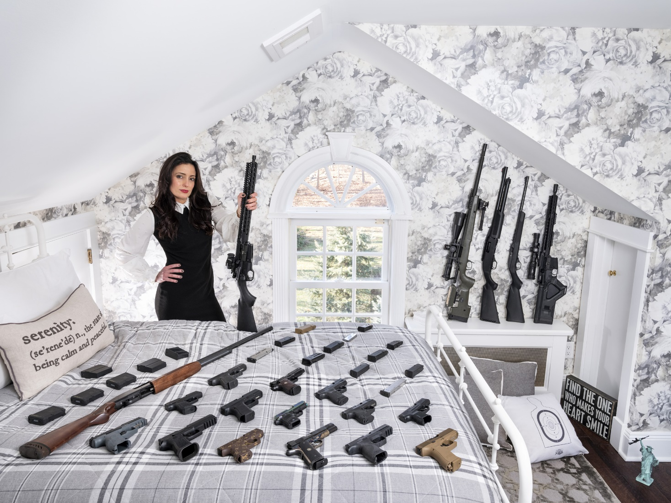
Ameriguns
Gabriele Galimberti

Problématique : to what extent does the possession of firearms and its restrictions highlight the difference between the USA and Australia?
Partie 1 : Similar traumas & contexts but contrasted reactions
Partie 2 : Difference in terms of politics & legal aspects
Partie 3 : A difference in terms of culture and identity
 | Document A | Document B | Document C
Partie 1 | - “1996” l.3 → same context than Columbine  - “visceral”, “backlash” l.27 → hyperbole, shows how strong the feelings were  - “less than two weeks” l.6 → shows the rapidity even though government takes time to change laws | - “Straightforward and severe”  - “650,000 privately held guns”  - “Suicides plummeted” | - Quantity of weapons → way too much, shows an inappropriate response, like traumatic response, more crime = being more armed  - Contrast between weapons and everything else → awkward, weird, not feeling safe
Partie 2 | - “six Australian states” l.6 → different organization in term of government, more difficult to agree when you’re 50  - “28-day waiting period, thorough background checks” l.8 → more hurdles to get weapons  - “halving” → important success  - “buying back” → giving motives to make things change  - “violence has not disappeared” l.14 → link with document B  - “laws banning semi-automatic rifles” l.7 → banning the most dangerous guns | - “The NFA also offered legal amnesty”  - “They’d pay the guns’ owners a fair price” | - Presence of automatic rifle → presence of a state where it is possible to have automatic rifle, difficulty to make the 50 states agree on that  - Lots of weapons → showing that there is no regulation in terms of quantity, contrasting with the Australian
Partie 3 | - “the American path” l.1 → distinguished from each other | - “Peacefully seized” → no resistance, contrasting with Americans | - “Ameriguns” →  - Statue of Liberty →  - Omni-presence of guns everywhere (statue of liberty, pillow, etc.)

